PRESS RELEASE

COMMUNICATIONS AND MEDIA TEAM OF THE 2023 ASEAN SUMMIT

No.56/SP/TKM-ASEAN2023/ENG/5/2023

Electric Car Drivers Proud to Participate in 42nd ASEAN Summit 2023

West Manggarai, 9 May 2023 – Hundreds of units of Electronic Vehicle/EV were deployed to transport delegates between venues of the series of events of the 42nd ASEAN Summit 2023 which is set to take place from 9 to 11 May 2023 in Labuan Bajo, East Nusa Tenggara (NTT).

Dewa Made (26), a young Balinese driver, was chosen as one of the drivers of the summit transport EV. He admitted that this assignment makes him proud because he can again be part of the success of the organization of an international event.

"I’m proud, apart from gaining experience, traveling to Labuan Bajo, more importantly I’m representing Indonesia. I'm just happy,” said Dewa Made when met at the Bintang Flores hotel area, Labuan Bajo, Tuesday (9 May).

Dewa admitted that it was not his first assignment as driver for international event. Dewa Made also took part in similar job in the previous 2022 G20 Summit in Bali.

"In 2022, I also became a driver. 90 Balinese drivers are reassigned here at the 2023 ASEAN Summit," said Dewa.

ASEAN countries have agreed to increase the contribution of renewable energy to 23 percent by 2025 and move towards a low-carbon future.

Assuming the Chair of ASEAN 2023, Indonesia is expected to be able to encourage all ASEAN Member States to bring about energy transition more aggressively. It is more like re-living the spirit of last year's G20 Presidency, when the energy transition was also a priority issue.

Energy transition is an increasingly actual issue over the next few decades and has become a commitment of the international community.

With abundant potential for renewable energy resources, Indonesia is considered to be able to play a bigger role in energy transition at the regional level. Aligned with its position as the Chair of ASEAN 2023, Indonesia can become a benchmark for energy transition in the Southeast Asian region.

Previously, Coordinating Minister for the Economic Affairs Airlangga Hartarto stated that the ASEAN Leaders' Declaration on Developing Regional Electric Vehicle Ecosystem was the first initiative document to serve as a guide for cooperation and collaboration to develop a safe, efficient, and sustainable electric vehicle ecosystem in ASEAN.

According to Airlangga, Indonesia has made a roadmap on renewable energy, also for digital and EV (Electric Vehicle) which will be combined with renewable energy, whether it is based on hydro or solar energy.

The series of events of the 42nd ASEAN Summit 2023 in Labuan Bajo will be attended by eight ASEAN country leaders, the ASEAN Secretary General, and Prime Minister of Timor-Leste, to discuss a number of issues of ASEAN’s common interests. (Ismadi/US/TR/Elvira/PPR)

***

For more information, please contact:

Director General of Public Information and Communications of the Ministry of Communications and Informatics – Usman Kansong (0816785320).

Get other information at http://asean2023.id, https://infopublik.id/kategori/asean-2023, and https://indonesia.go.id/kategori/ragam-asean-2023

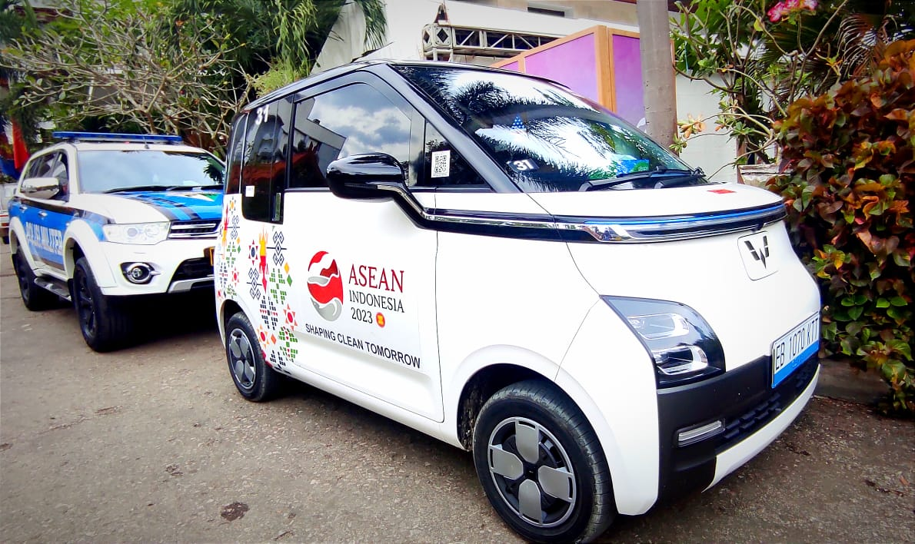

Hundreds of units of Electronic Vehicle/EV units were deployed deployed to transport delegates between venues of the series of events of the 42nd ASEAN Summit 2023 which is set to take place from 9 to 11 May 2023 in Labuan Bajo, East Nusa Tenggara (NTT) (Photo: Agus Siswanto/InfoPublik)

